SkillsBooster

Enhance your skills with SkillsBooster

Kazalo vsebine

1 Index 2

4 Description 3

5 Documentation 3

5.1 Functionalities 3

5.2 Architecture 4

5.3 Teamwork 4

6 Technologies 4

6.1 AI 4

6.2 Firebase 5

6.3 Cloud Firestore 5

6.4 JavaScript 5

6.5 Vite 5

6.6 React JSX 5

7 Installation 5

7.1 Backend 5

7.2 Frontend 5

8 Testing 6

8.1 Testing tool 6

8.2 Test Scenario 6

8.3 Deployment 6

8.4 Optimization 6

9 User Manual 6

# Description

Our platform offers a comprehensive tool designed to support companies in evaluating and developing their employees' knowledge through customizable self-assessment questionnaires and AI-generated learning contend.

The solution aids management in ensuring the continuous growth of their team's skills

# Documentation

## Functionalities

**Knowledge Domain Management:**

* Easily add and manage knowledge domains
* Define and edit key competencies within each domain

**Question Management**

* User-friendly interface for creating, editing and deleting questions within a domain
* Option to include correct and incorrect answers for each question
* Link questions to theoretical knowledge or relevant learning resources

**AI Integration**

* AI-powered generation of simple answers
* Analysis of user responses to identify knowledge gaps
* Automated suggestions for knowledge improvement, including learning materials based on incorrect answers.

**Learning Material**

* Link or upload learning materials such as articles, videos, e-books, or web resources relevant to knowledge enhancement.
* Organize learning materials by domain and specific competencies.

**Skills Matrix Generation**

* Track employee progress and compare knowledge levels
* Automatically generate and update a Skills Matrix based on employee progress
* Responsiveness and Accessibility
* Intuitive and uer-friendly interface for easy navigation and use
* Accessible on various devices (computers, tablets and smartphones) with adaptability to different screen sizes

## Architecture

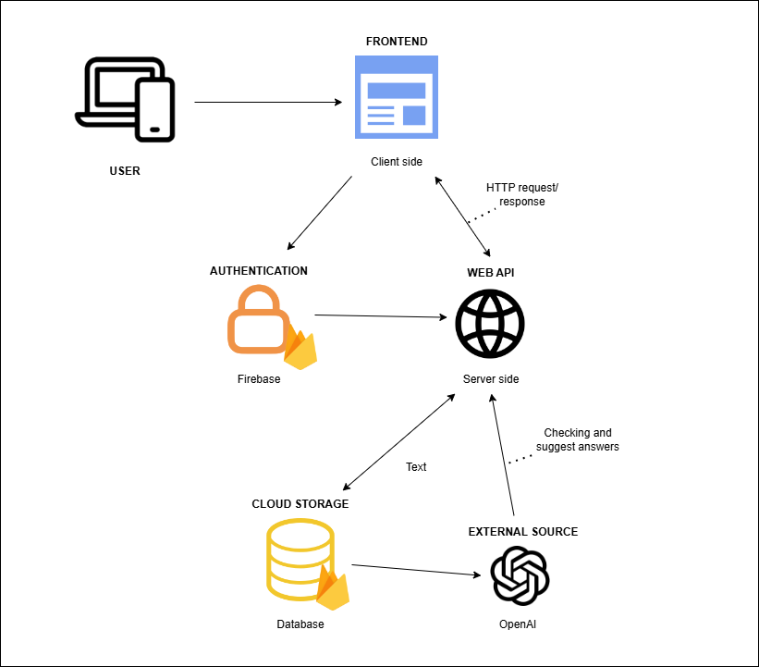

## Teamwork

The work was done in **sprints**, which lasting form 7-10 days, which allowed us to be on track with tasks and solve any problems that occurred in between.

We held **weekly meetings**, by the end of the week, to evaluate the work that was done and split the tasks that need to be done in the following week.

To track our progress we used **Kanban table,** using Trello site, which allowed us to not only assign the tasks to a specific member, but also add **priority** to a specific task. The highest priority was done first, those with minor importance, were later assigned to members.

Slika, ki vsebuje besede besedilo, posnetek zaslona, programska oprema, računalniška ikona

Opis je samodejno ustvarjen

## Communication

Between the members of the project, the communication was held daily, using Discord app. Since Discord allows users to have video calls, we held our meetings at the end of the week on discord, for each member to show the work that he done.

Communication with our mentor was in person or via Teams app, where we presented our progress and set goals for the next meeting.

As for tracking our progress, we used GitHub where all project code is saved. It also provides us an insight in previous versions of the application and tracking changes.

# Technologies

## AI

OpenAI is a leading artificial intelligence research organization and technology company focused on developing and promoting AI technologies in a safe and beneficial way. Founded in December 2015 by Elon Musk, Sam Altman, and others, OpenAI aims to advance digital intelligence to benefit humanity. The company has made significant strides in AI research and has created some of the most well-known AI models, including GPT (Generative Pre-trained Transformer) models, which power applications like ChatGPT

## Firebase

Firebase is a comprehensive platform developed by Google for building mobile and web applications. It provides a variety of tools and services that help developers build, improve, and scale their apps without managing the underlying infrastructure.

## Cloud Firestore

Cloud Firestore is a flexible, scalable database for mobile, web, and server development from Google Firebase. It is a NoSQL document database, meaning it stores data in documents and collections instead of traditional rows and tables, which allows for more hierarchical and nested data structures.

## JavaScript

Is a high-level, interpreted programming language that is one of the core technologies of the World Wide Web, alongside HTML and CSS. It is a versatile language primarily used for creating dynamic, interactive content on websites and web applications, though it has also expanded to other domains, including server-side development, mobile app development, and even desktop applications.

## Vite

Vite is a modern build tool that provides a fast and efficient development experience for web applications. Created by the developer behind Vue.js, Vite is designed to address the performance limitations of traditional build tools like Webpack, especially in large projects.

## React JSX

A syntax extension for JavaScript that is specifically designed to be used with React. It allows developers to write HTML-like code directly within JavaScript files, making it easier to create and manipulate user interfaces in a declarative manner.

# Installation

## Backend

## Frontend

# Testing

## Testing tool

We have used this testing to help us test different functionalities of our site

## Test Scenario

## Deployment

**Vercel** is a cloud platform that enables developers to deploy, manage, and scale modern web applications with ease. It’s particularly popular among frontend developers and teams working with frameworks like Next.js, which was also developed by Vercel (formerly known as Zeit). Vercel focuses on providing a seamless experience for deploying serverless applications, static websites, and other web projects.

## Optimization

**SonarCloud** is a cloud-based code quality and code security service that helps developers ensure their code is reliable, maintainable, and secure. It is part of the SonarQube ecosystem, developed by SonarSource, and provides static code analysis to identify bugs, vulnerabilities, code smells, and technical debt in your codebase. SonarCloud is used by developers and teams to maintain high standards of code quality throughout the development process.

# User Manual

You can find User Manual in a separate file “SkillsBooster User Manual” in the folder: Documentation, on our repository, where everything is described in detail on how to use our website.